1 Hour
Everything except for Exersise 10-5 went well I feel
I did struggle to get write_text to apphend text to a file in a way I liked
As always here’s the output (ignore me misspelling my name in the output). I feel the text files are part of the output to so I will also upload those.
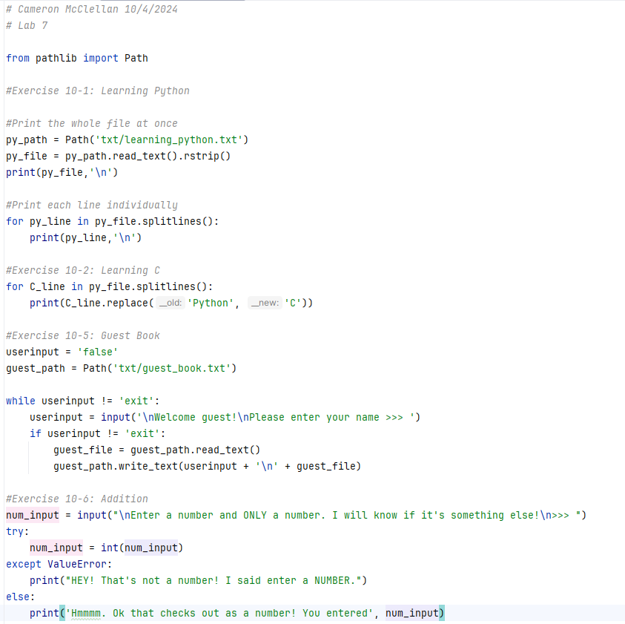
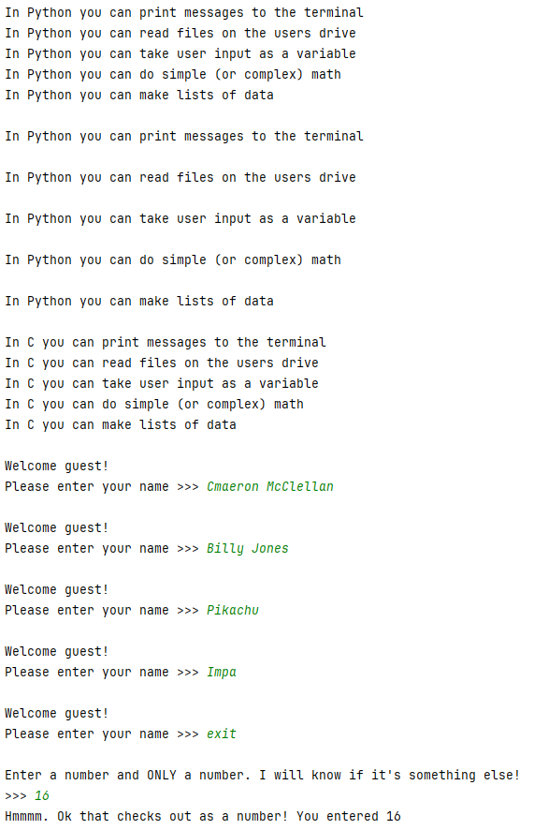
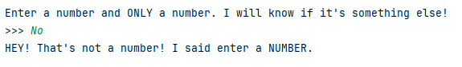
If exception is raised:

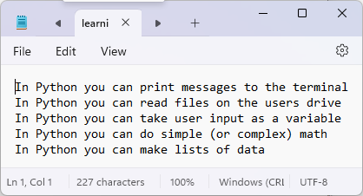
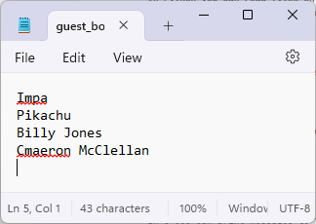
Text files:

